Chat Bot to shop essentials during pandemic using Watson Assistant

# What is Chat Bot?

# A chat Bot is a software application used to conduct an on-line chat conversation via text or text-to-speech, or speech to speech in lieu of providing direct contact with a live human agent. Main purpose of the chat Bot is to provide preliminary information about the entity like company, college, school like wise. It also handles frequently asked questions and saves human working hours.

# Importance of Chat Bot

A chat bot is often described as one of the most advanced and promising expressions of interaction between humans and machines. However, from a technological point of view, a chat bot only represents the natural evolution of a Question Answering system leveraging Natural Language Processing (NLP).Formulating responses to questions in natural language is one of the most typical Examples of Natural Language Processing applied in various enterprises’ end-use applications.

**1) User request analysis**

User request analysis: this is the first task that a chatbot performs. It analyzes the user’s request to identify the user intent and to extract relevant entities.

**2) Returning the response**

Returning the response: once the user’s intent has been identified, the chatbot must provide the most appropriate response for the user’s request.

**Major Objective of proposed system is**

* To provide facility to see the menu
* To provide facility to place the order of the item
* Accept the order
* Inform the user that order has been placed

**Services Used:**

* 1.IBM Watson Assistant
* 2.Node-Red

**Implementation & Result Screenshot**

In IBM Watson Assistant major components to build chatbot are Intent, Entities & Dialogs. There are four intents made in proposed system each of which will separately take care of each goal of bot.

**Intents**

1. Greetings Intent-: It takes care of initial user responses

2. Welcome Intent-: It takes care of informing user what this Chat Bot does.

3. Enquiry Intent-: It takes care of shopping items enquiry

4. Order Intent-: It takes care of placement of order

# Intents

# Entities

# Dialog

# Welcome: This is the default one provided by the Watson service

# Greetings: This node is created to manage all greeting related exchange of discussion.

# Enquiry : This node will handle all types of enquiries related to

# Shop opening hours

# Menu card

# Asking for help

# Order: This node helps in placing orders

# Thank you: This node will give response to thank you message of the user.

# How Chatbot works?

There are two different tasks at the core of a Chat Bot:

1. **User request analysis**

User request analysis: this is the ﬁrst task that a Chat Bot performs. It analyzes the user’s request to identify the user intent and to extract relevant entities.

1. **Returning the response**

Returning the response: once the user’s intent has been identiﬁed, the chatbot must provide the most appropriate response for the user’s request.

# Major Objective of proposed system is

* To Provide list of items available.
* To take order once item is selected
* To place order

# Services Used:

1.IBM Watson Assistant 2.Node-Red

# Implementation & Result Screenshot

In IBM Watson Assistant major components to build chatbot are Intent, Entities & Dialogs. There are four intents made in proposed system each of which will separately take care of each goal of bot.

# Intents

1. Greetings Intent-: It takes care of initial user responses
2. Welcome Intent-: It takes care of informing user what this chatbot does.
3. Enquiry Intent-: It takes care of shopping items enquiry
4. Order Intent-: It takes care of placement of order

# Screen shorts:

# Intents:

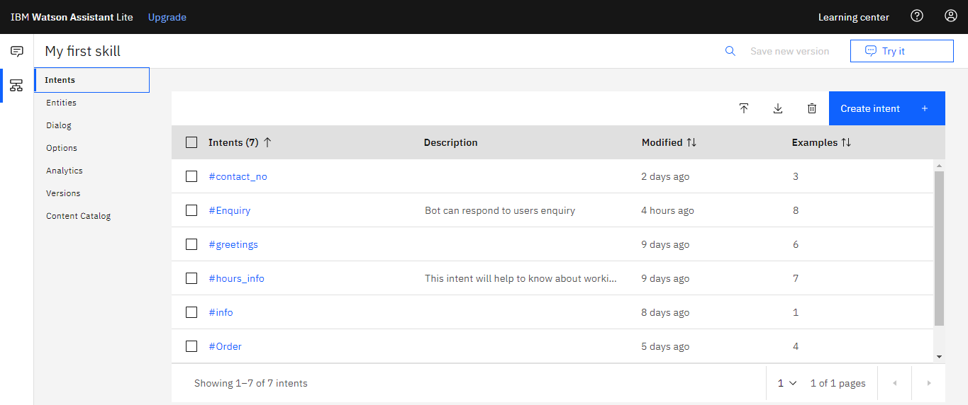

1. **Entities :**

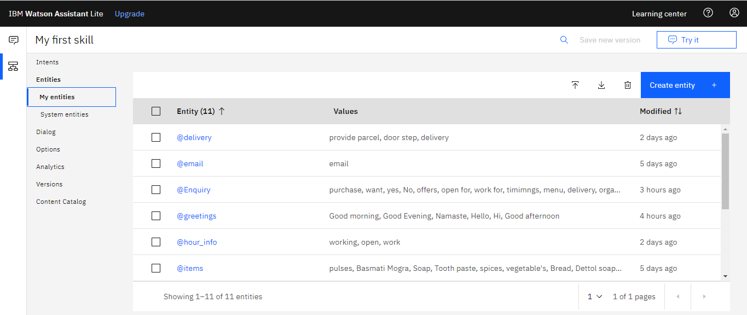

1. **System Entities :**

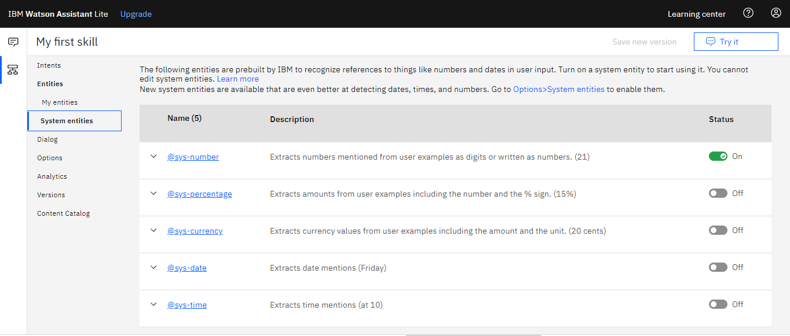

1. Dialogs :

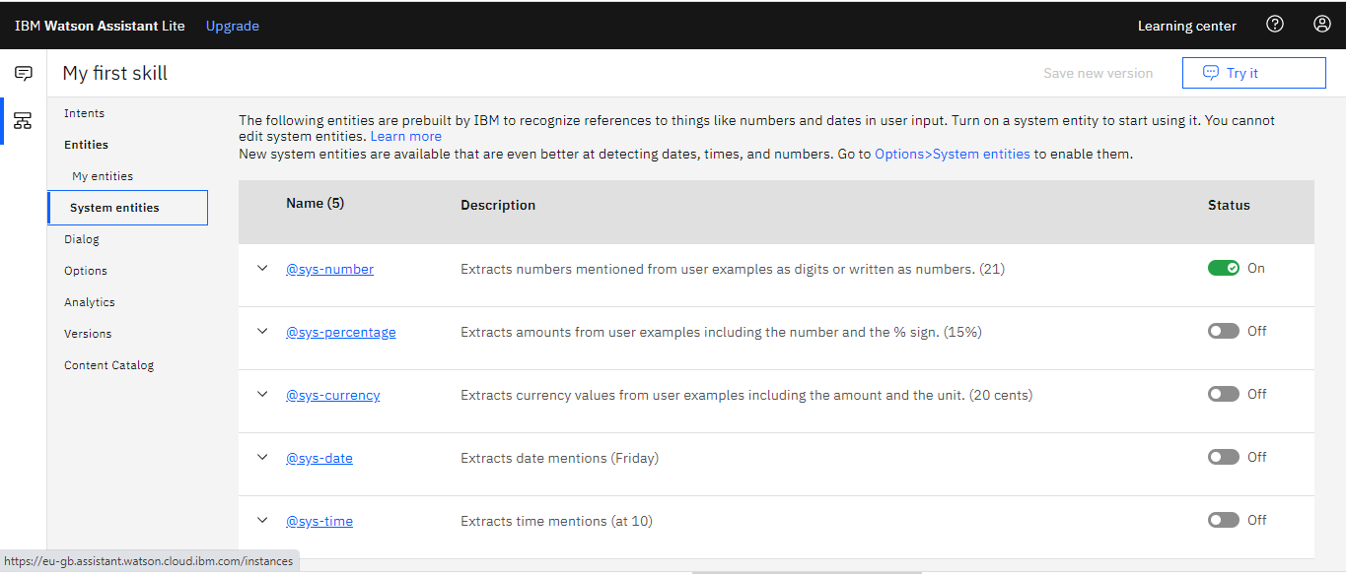

1. Creation of BOT link

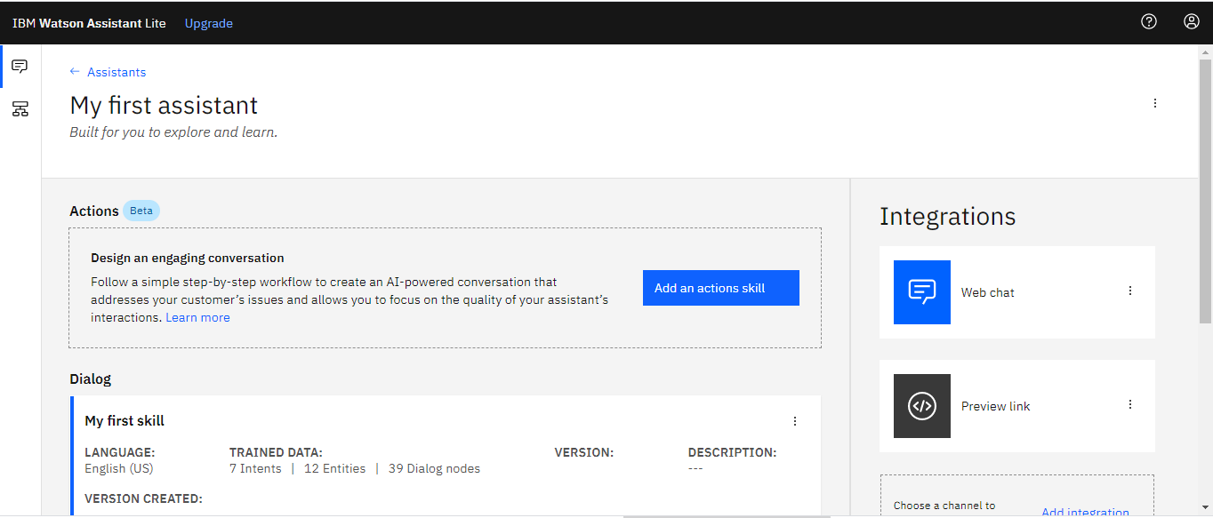

1. **Result & screen shorts**

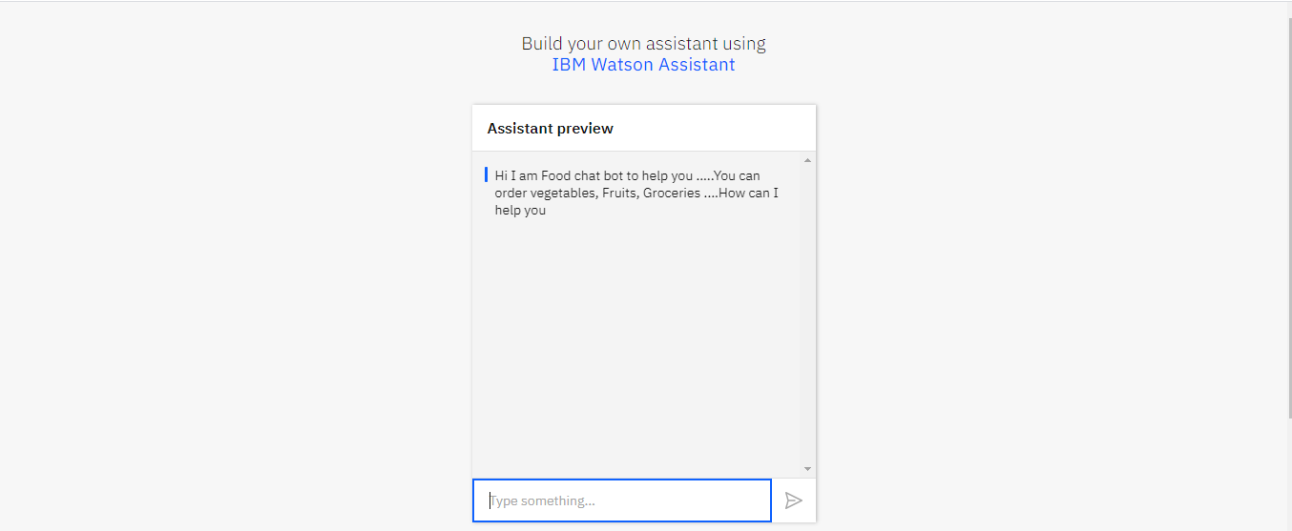

1. **User asking for menu card :**

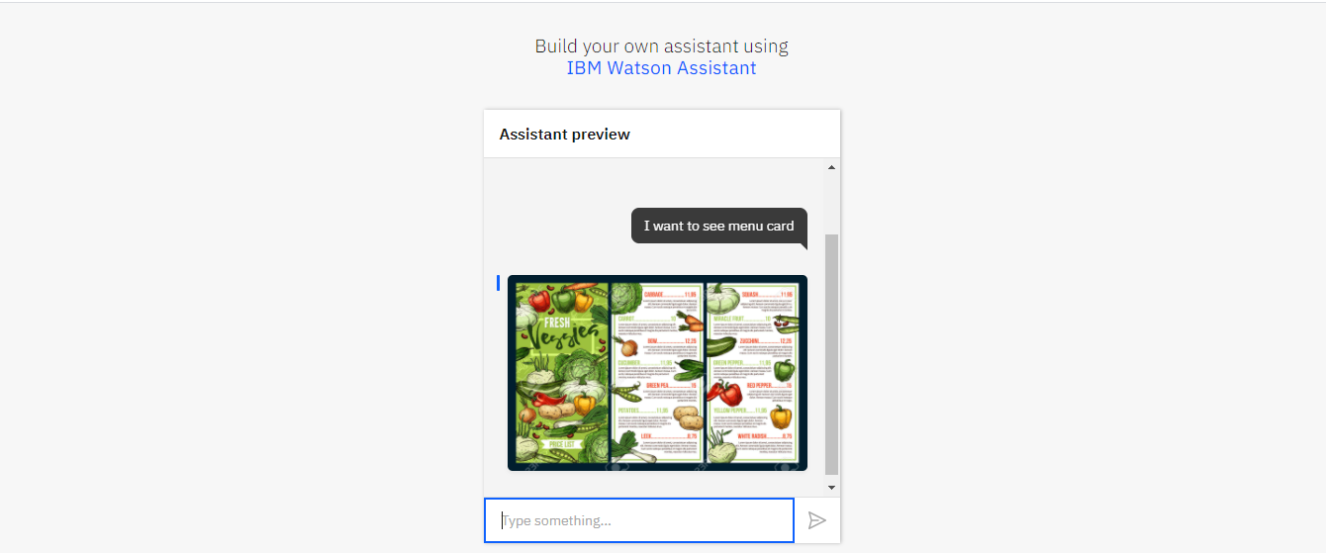

1. **User asking for offers:**

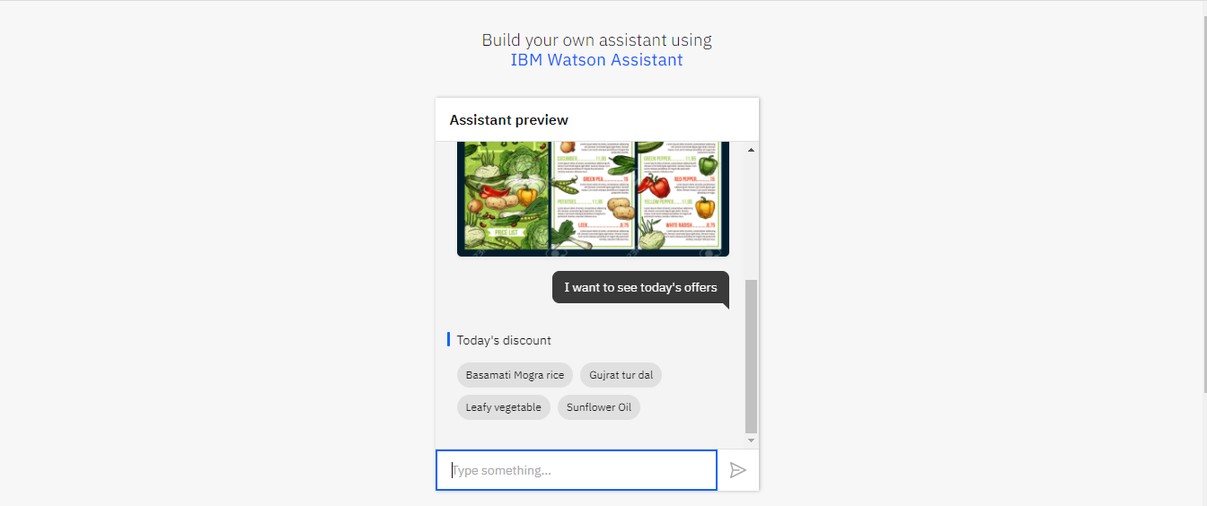

1. **Bot asking user put mail id for placing order:**

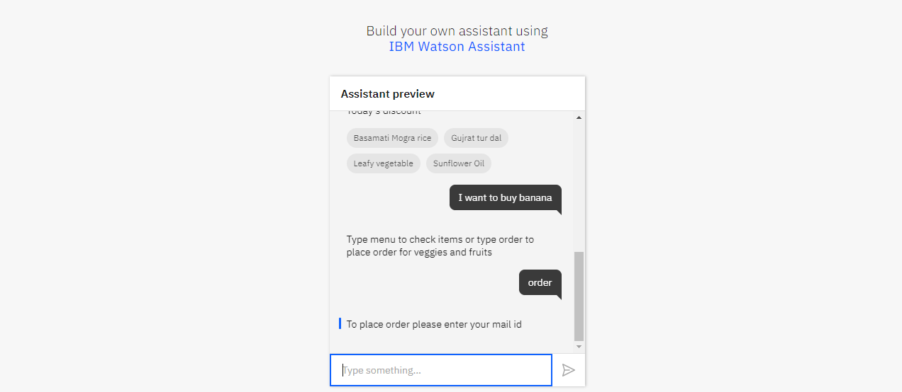

1. **Selection of item:**

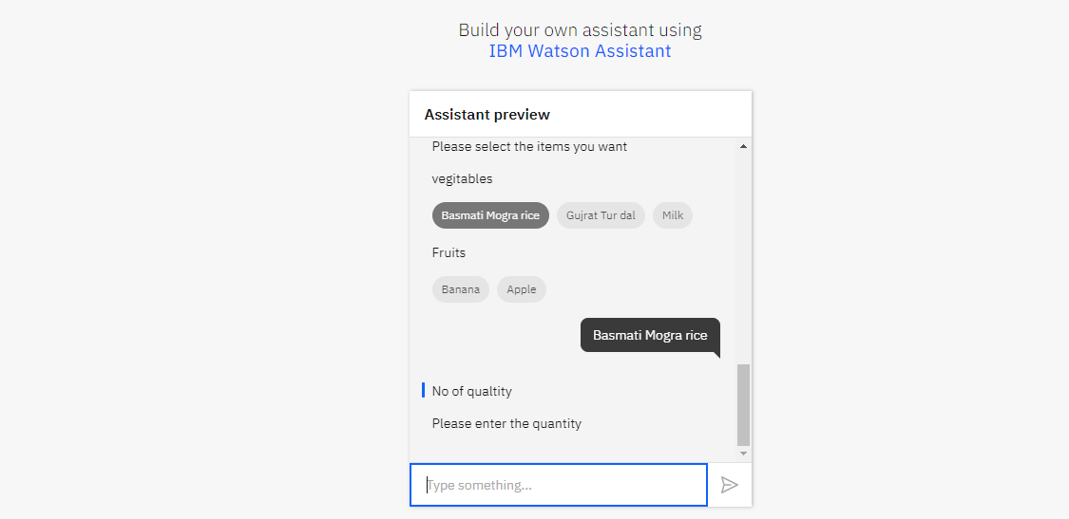

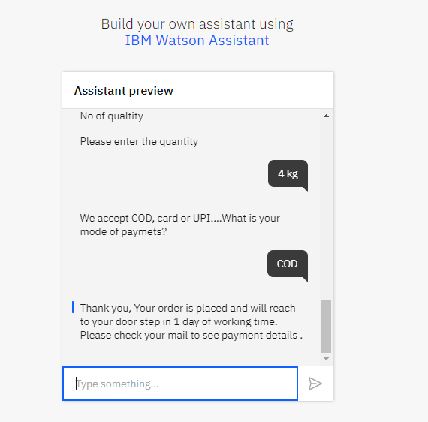

1. **Handling closing discussion :**

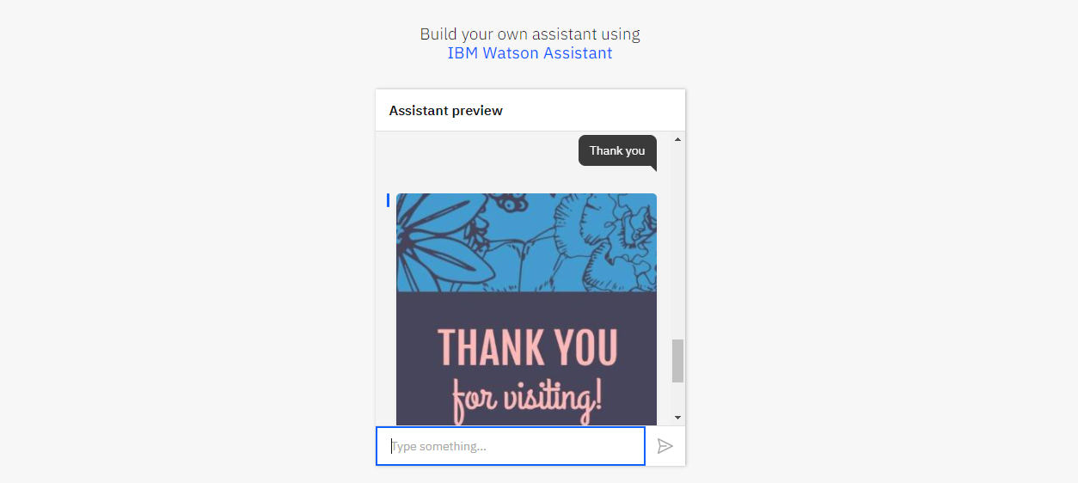

1. **Screen shorts of Node red:**

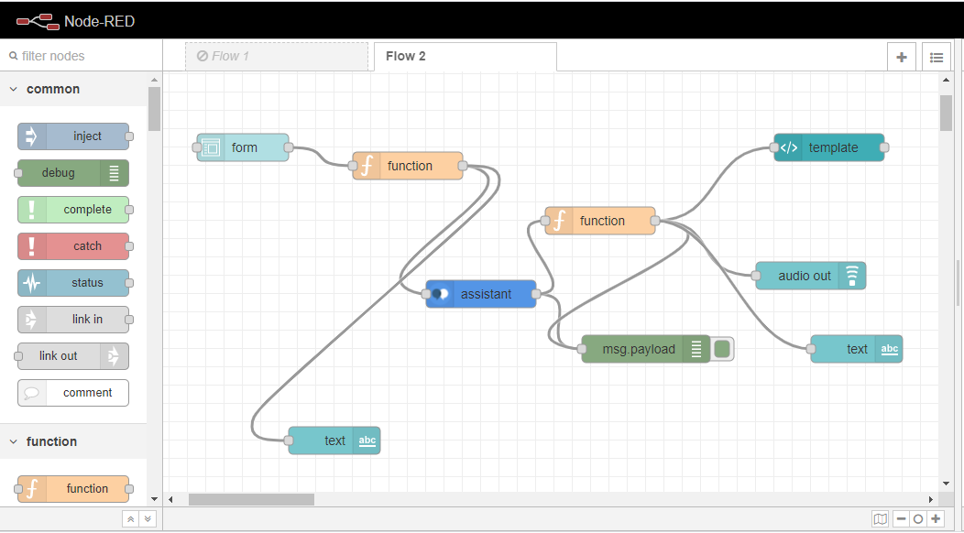

1. **UI screen shorts**

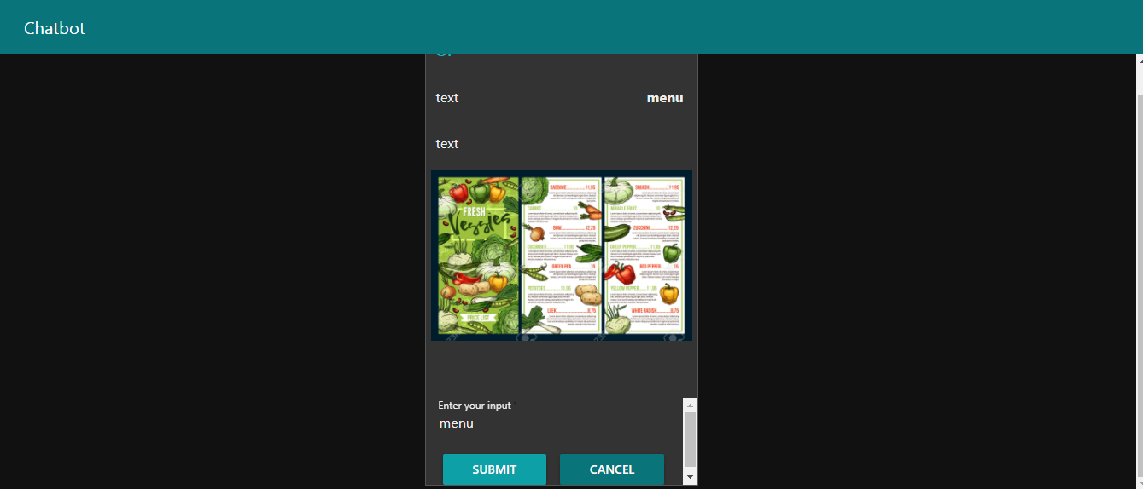

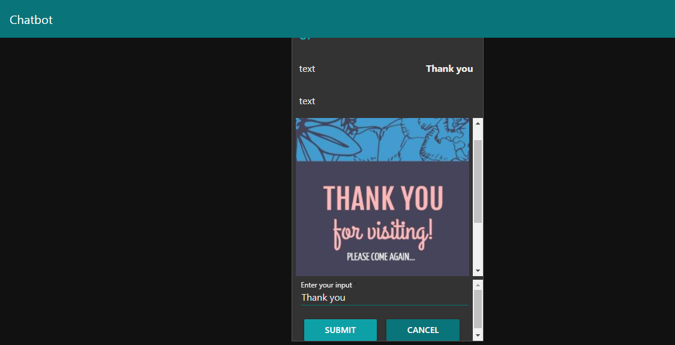

**Conclusion:** This bot will help user to see the items, check the offers and place the orders.